5-Day WFR Study Guide



The Wilderness First Responder (WFR) Study Guide is intended to aid you in your review of key material included in Wilderness Medical Associates International’s WFR curriculum. We strongly encourage you to read the textbook WARM (Wilderness and Rescue Medicine) completely before beginning this Guide and taking the online test. WARM covers all of the questions posed in the Guide.
You are required to fill this Guide out completely and pass it in at the beginning of the first day of your course.

General Principles of Physiology and Pathology
Oxygenation and Perfusion
What is the difference between perfusion and oxygenation?

Why are both of these important in the body?

Body Systems
List the three critical systems:

Compensation Mechanisms
What is meant by compensation and how do compensation mechanisms help with patient assessments?

Give examples:

Mental Status and Level of Consciousness
What are your two primary concerns with a patient with an abnormal mental status/level of consciousness?

Swelling
What are two sources of swelling?

What is the serious anticipated problem of swelling?

Ischemia and Infarction
What is the difference between ischemia and infarction?

Patient Assessment System
Scene Size-up
List the three sub-components:

What is meant by mechanism of injury (MOI)? List three examples:

Primary Assessment
What is the main goal of a primary assessment?

Secondary Assessment

List the three subcomponents:

Physical Exam
Describe an effective physical exam?

SAMPLE History
What does each letter in the acronym SAMPLE stand for?

Vital Signs
List six vital signs we can assess:

What does each letter in the acronym AVPU stand for?

Circulatory System
System Overview
List the three major components of the circulatory system:

Describe the main function of the circulatory system:

What is shock?

Volume Shock
List three common causes of volume shock:

Describe the vital sign trend for compensated and decompensated volume shock:

Describe the treatment principles for volume shock:

When is volume shock considered a serious problem requiring evacuation?

Cardiogenic Shock
What is cardiogenic shock and how does it differ from a cardiac arrest?

List two common mechanisms for cardiogenic shock:

Vascular Shock
What is meant by the term vascular shock?

List two common mechanisms for vascular shock:

Describe the treatment principles for vascular shock:

Acute Stress Reaction (ASR)
Define the two types of ASR and how they manifest themselves:

Explain how each could affect your assessment or treatment:

Respiratory System
System Overview
List the five components of the respiratory system:

List the general problem associated with each component (i.e. upper airway: obstruction):

What is the basic treatment for all respiratory system problems?

Describe respiratory distress, failure, and arrest: Include in your answer how they differ.

Respiratory System Problems
For each component of the respiratory system, list two specific problems and the treatment.

Central Nervous System
System Overview
What does each letter in the acronym STOPEATS stand for? Why are they important?

Traumatic Brain Inury (TBI) and Increased Intracranial Pressure (ICP)
What is increased ICP and what is its significance?

What is a TBI: What is the anticipated problem?

Describe the early and late assessment criteria for increased ICP:

After a blow to the head, which signs/symptoms should prompt an evacuation?:

Stroke
Describe the different causes of a stroke:.

List some common signs and symptoms that can occur with a stroke:

Describe the management principles involved with a stroke:

Seizures
How is a seizure best managed?

Spine Management
System Overview
What is the difference between spinal column and the spinal cord? What is the function of each?

Assessment of Spine injuries
List the steps of the Spine Assessment Protocol in detail:

Describe what is meant by a reliable patient and an unreliable patient:

Following an MOI (e.g., trauma), which criteria must be fulfilled before a spine can be considered cleared ?

Movement of injured spines
Describe the principles utilized when moving a spine injured patient:

Do all spine injured patients require stabilization before being moved? Please explain your answer.

Basic Life Support
BLS vs ALS
Define each including the differences in skills:

CPR Protocol
Explain why there is a need for special CPR Protocol:

How does it differ from conventional expectation?

Basic Life Support – Respiratory System
Respirations
Describe techniques for maintaining an open airway:

Describe adequate breathing:

Describe the principles of effective rescue breathing:

Basic Life Support – Respiratory System
Foreign Body Airway Obstruction
Describe how to differentiate between a partial and complete obstruction:

Describe the treatment for complete airway obstruction:

Basic Life Support – Circulatory System
Pulse
Describe the proper sequence of actions for CPR (adult, child and infant):

Basic Life Support – Circulatory System
Severe Bleeding
Describe a rapid trauma assessment (blood sweep) looking for serious bleeding:

List and describe some effective ways to stop bleeding:

Basic Life Support – Nervous System
Level of Consciousness
When a patient is less than A on AVPU, what are the anticipated problems?

Basic Life Support – Tools and Equipment
Mouth to Mask
Describe how to use a pocket mask and include the proper rate and depth of PPV.

Basic Life Support – Tools and Equipment
Automatic/Semi Automatic External Defibrillator (AED/SAED)
Describe the function of an AED/SAED and it’s purpose:

List a limitation of an AED/SAED:

Allergy and Anaphylaxis
Outline the treatment for a local reaction and a mild allergic reaction:

Anaphylaxis Protocol
Which signs and symptoms should prompt a rescuer to initiate this protocol?

List the medications used to treat anaphylaxis: Include the dosages, routes of administration, and some common side effects:

After the initial treatment, what is your anticipated problem? How is it treated?

Asthma
Asthma Protocol
What conditions must be satisfied before this protocol can be initiated?

List the medications named and their dosages: Who needs to be evacuated?

Hypoglycemia
Diabetes
What are the assessment criteria and treatment guidelines for hypoglycemia?

Musculoskeletal
System Overview
What are some of the functions of the musculoskeletal system?

Assessment of Injuries
What is meant by a stable and an unstable injury? How do they differ?

What is included in a CSM check? What does an abnormal assessment indicate?

Treatment of Injuries
Stable Injuries
How should a stable injury be managed?

Unstable Injuries
List the treatment steps used to care for an unstable long bone injury:

How are joints managed differently? Why?

Splinting Principles
What general principles should be applied when constructing a splint?

What is a compartment syndrome?

Is a traction splint always indicated for a suspected unstable injury of the femur? Explain.

Dislocations
System Overview
According to the Dislocation Protocol, which joints may be reduced?

Why is the mechanism of injury an important consideration?

Outline a reduction technique for each of the dislocations you listed above:

Wounds and Burns
System Overview
What is the normal function of the skin?

Describe the normal healing process following a soft tissue injury:

What is the risk in a high risk wound? List 4 examples of high risk wounds:

Wound Protocol
Describe the wound cleansing process:

What are the roles and practical concerns around the use of sutures or wound closures?

How should amputations be managed?

Describe the protocol for impaled objects/foreign bodies.

Infection
What are the signs of a localized infection? Systemic infection?

What are the treatment principles for wound infections?

Burns
Describe the assessment criteria of each of the following burns:
Superficial:
Partial Thickness:
Full Thickness:

List some of the complications associated with large body surface area burns:

How are burns treated?

Thermoregulation
Thermoregulatory considerations
What are the mechanisms by which heat is transferred away from the body?

How does the body retain, produce and dissipate heat?

Hypothermia
Mild Hypothermia
What are the assessment criteria?

What is the treatment?

Severe Hypothermia
What are the assessment criteria?

Describe field stabilization and treatment.

What are the complications associated with severe hypothermia?

Heat Related Illnesses
Mechanism
Besides the temperature, what other factors contribute to heat related illness?

Heat Stroke
What are the main causes of heat stroke?

What are the assessment criteria?

What is the treatment?

Is heat stroke always preceded by the onset of heat exhaustion? Explain.

Exertional Hyponatremia
List some common preconditions and causes.

What are the assessment criteria?

What is the treatment?

How can this be distinguished from heat exhaustion and heat stroke?

Cold Injuries
What conditions and factors predispose a person to frostbite?

List the pretreatment assessment criteria and treatment for each of the following:
Frostnip:
Superficial:
Deep:

When can deep frostbite be thawed safely? Explain your answer.

What is a non-freezing cold injury? When does it occur?

Altitude
List the primary stress confronted at altitude.

List the signs, symptoms, and treatment for the different stages of HACE.

List the signs, symptoms, and treatment for the different stages of HAPE.

Give specific examples of how altitude sickness can be prevented.

Submersion
List some of the general contributing factors to drowning:

What is the primary problem with drowning and how is it managed?

Is CPR indicated on all drowning patients? Explain your answer:

Lightning
DC Injuries - Mechanism
What are some of the warning signs that a lightning strike may be imminent?

Describe the following types of lightning strikes:
- Direct hit:
- Splash-over:
- Ground current:

Assessment
What types of associated injuries should be anticipated in lightning victims?

Treatment
Why is basic life support a critical treatment consideration?

Prevention
Describe some of the important considerations in preventing lightning strikes?

Toxins, Bites and StiNGs
What are the four ways that toxins enter the body?

What are the general principles of toxin exposure management?

Marine Toxins
List two examples and describe the treatment for each.

Pit Vipers
Name examples of pit vipers in North America:

What are the assessment criteria for a pit viper envenomation?

What are the treatment principles for pit viper bites?

Arthropod Disease Vectors
Ticks
How can tick bites be prevented? How do you remove a tick?

List some common signs and symptoms associated with many tick-borne illnesses.

Backcountry Medicine
Treating Pain
Before resorting to medications, what principle is important in managing pain?

Abdominal Pain
What are the red flags for abdominal pain?

Chest Pain
List some common causes for chest pain and their treatments.

What are the red flags for chest pain?

Diarrhea
List some common causes of the diarrhea.

How can it be treated; prevented?

What are the red flags for diarrhea?

Constipation
List some common causes of constipation.

How can it be treated; prevented?

Nausea and Vomiting
List some common causes.

How can it be treated; prevented?

What are the red flags for nausea and vomiting?

Ear Problems
List the common assessment criteria, treatment, and any preventive strategies for the following:
Middle Ear Infection (Otitis Media):
External Ear Infection (Swimmer’s Ear):
Sinusitis (Sinus Infection):

What are the red flags for ear and sinus infections?

Nosebleed
List the common causes, treatment, and preventive strategies for nose bleeds.

What are the red flags for nose bleeds?

Urinary Tract Infections (UTI)
List the assessment criteria for the common forms of UTIs.

List treatment and preventive strategies for each

What are the red flags for urinary tract infections?

Vaginitis
List the assessment criteria for the common forms of vaginitis:

List treatment and preventive strategies for each:

What are the red flags for vaginitis?

Respiratory Infections
List the assessment criteria for some common forms of respiratory infections:

List the treatment and preventive strategies for each:

What are the red flags for a respiratory infection?

Dental Trauma and Infections
List the important assessment criteria for dental trauma and infections:

List the treatment and any preventive strategies for each:

Eye Problems
List assessment criteria, treatment, and preventive strategies for each:
Foreign Body:

Corneal Abrasion:

Conjunctivitis (Pink Eye):

Solar Keratitis (Snow blindness):

What are the red flags for eye problems?

Case Studies
5-Day WFR
The following case studies are provided to give you an opportunity to utilize the information that you have learned from WARM in a practical way. The first is a sample case study including a completed SOAP note to demonstrate how to proceed. Even though this exercise is likely new for you, try your best focusing especially on formulating a clear problem list (Assessment).

In the next part of this guide you will find seven (7) case studies. Begin by reviewing the first one. It provides a sample of how this next assignment should be completed. From the remaining six (6), pick any two (2) and answer the questions that follow each case study and complete a SOAP note for each. Keep in mind the general principles of wilderness medicine, as well as WMA’s wilderness protocols, and consider risk/benefit calculations in your assessments and treatment decisions.

Bring your two (2) written SOAP notes and answers to your course as they may be collected on the first day.

Sample- Fall Descending – New Mexico

A 54 y/o male fell while descending a ridge on a peak in New Mexico. The route was considered 4th class and was a popular way to get up and down the mountain. The pt. lost his footing and tumbled down a steep snow slope, gaining speed, before cartwheeling into a rocky area at the base. The pt. was able to crawl to an overlook over the descent trail and call to another group for help. This group was 1000΄(300 m) below the pt. and began their 5 mile (8 km) descent to a National Park Service ranger station to seek help. Rescuers arrived 3 hrs. after the fall to find their pt. lying on his right side, alert and oriented, c/o severe pain in his right thigh, and pain in his right wrist. He stated he was allergic to morphine, took ibuprofen for chronic knee pain, had no other pertinent medical history, had some food and water 2 hrs. previously with his last urine output at that time, and remembered the fall vividly, denying a loss of consciousness. The pt. stated he was wearing a helmet at the time of the fall. On exam, the pt. was non-tender to the head, neck, chest, abdomen, pelvis, and spine. The pt. had some significant bruising, swelling, and was very tender on the right thigh with significantly reduced range of motion due to the pain. Swelling and tenderness was noted in the right wrist with normal range of motion and although somewhat painful, the pt. was able to flex and extend against resistance. Vitals at 1600hrs. were: Pulse: 76, Resp.: 16, E/P: 134/82, Skin: warm and normal in color, Pt. was awake, oriented, calm, and uncomfortable. Put the appropriate information from the story above into the correct spaces provided in the SOAP note to the right. After you’ve completed the Subjective and Objective sections, develop an Assessment for 1600hrs. with Anticipated Problems and an appropriate Treatment Plan listed in the columns to the right.

Put the appropriate information from the story above into the correct spaces provided in the SOAP note.
After you've completed the Subjective and Objective sections, develop an Assessment for 1600hrs. with
Anticipated Problems and an appropriate Treatment Plan listed in the columns to the right.

Vitals were repeated at 1630hrs.: Pulse: 80, Resp.: 16, E/P: 128/78, Skin: normal, Pt. was Alert and Oriented and uncomfortable from the pain in his leg. No new exam findings were noted as the pt. was prepared for evacuation. Evacuation by NPS helicopter was completed at 1700hrs: Pulse: 72, Resp.: 14, E/P: 130/p, Skin: normal, Pt. is Alert and Oriented.

Again, put the important information from the update above into the correct spaces in the SOAP note.

Question
- 1. Based on the information you have through 1700hrs., do you think this patient is stable or critical?
* Answers to questions featured here are not provided in the “Answers” section on the back of each story, but are meant to inspire discussion with your instructor and fellow students.
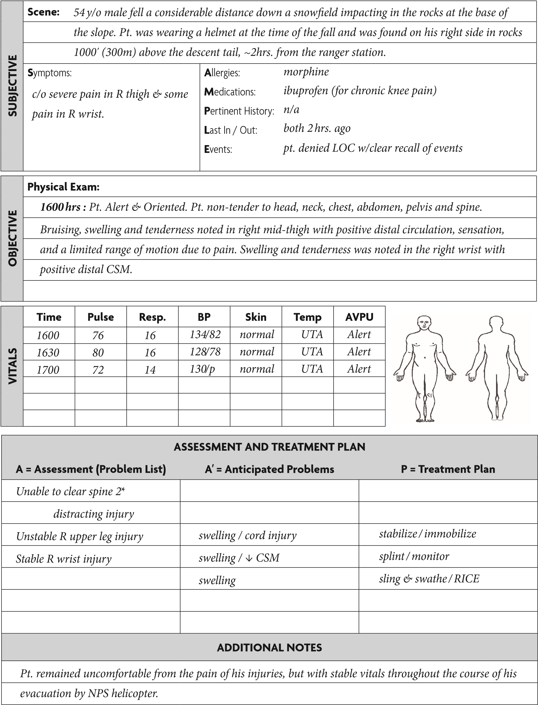

Respiratory Distress, Portaging

A group of canoeists on a four-day trip through the Boundary Waters stopped during a portage, when a 17 y/o male complained of difficulty breathing while lugging a canoe and oversized dry bags over the difficult terrain. The rest of the party took a break while two of the group leaders assessed the young man. At 1000 hours, the pt. complained that his chest felt “tight.” He was able to speak three to four words at a time but he said he was unable to catch his breath. The pt. had a history of asthma and used an albuterol inhaler as needed, but he did not bring it with him on this trip. He stated he had no allergies. He stated that his breathing got progressively worse during the portage, until he had to stop. His first set of vitals were: Pulse: 120; Resp: 24; Skin: warm and sweaty; mental status: alert and very anxious.

Put the appropriate information from the above story into the correct spaces provided in the SOAP note.

Develop an Assessment, identify the anticipated problems, and create a treatment plan for this patient, based on what you know at 1000 hours.

Over the next thirty minutes, the group leaders reassured the patient, had him rest, and encouraged him to take slow and deep breaths. His breathing improved considerably. The patient noted that he did not commonly experience severe asthma attacks, and last time he suffered a significant attack was a year prior, while he exercised in the cold. A repeat set of vitals, obtained at 1015, were as follows: Pulse: 84; Resp: 18 and easy; Skin: warm and dry; mental status: alert with resolving anxiety.

Modify your SOAP note to include this new information.

Questions:

- If the patient in this case study did not respond to PROP and if his condition actually worsened, which signs and symptoms would indicate that he had moved to respiratory failure?

- Once an asthma patient progresses to respiratory failure, what are the ideal medications (and dosages of each) that you would use to treat the problem?

- When would you consider a “high risk” evacuation for a patient who is experiencing a respiratory problem?

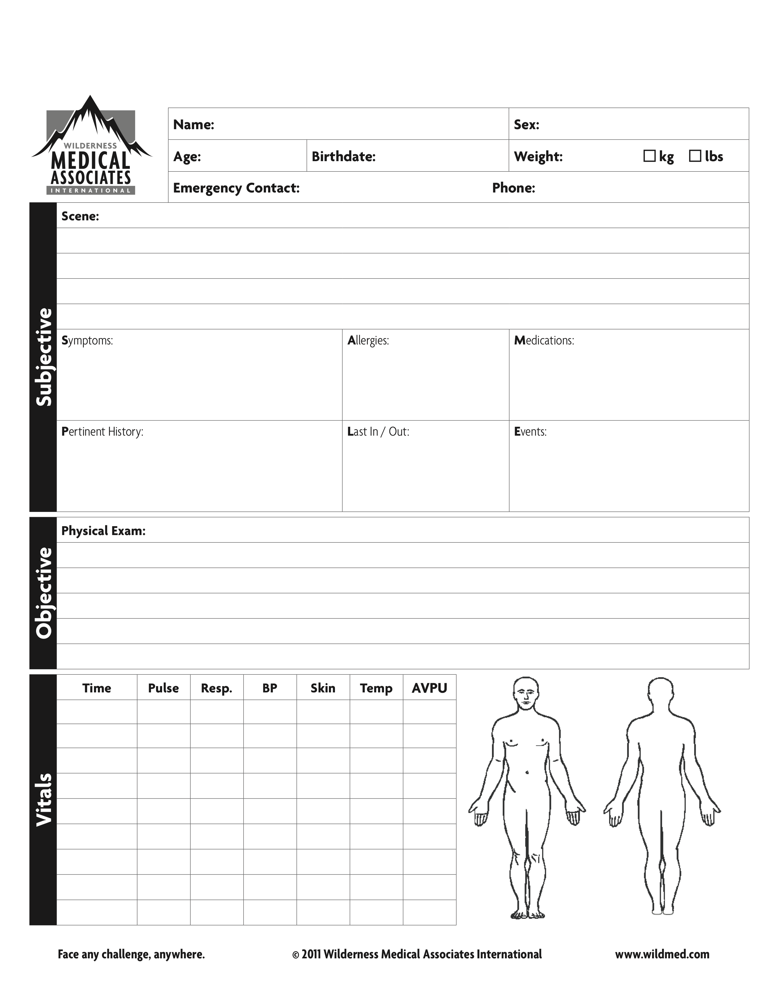
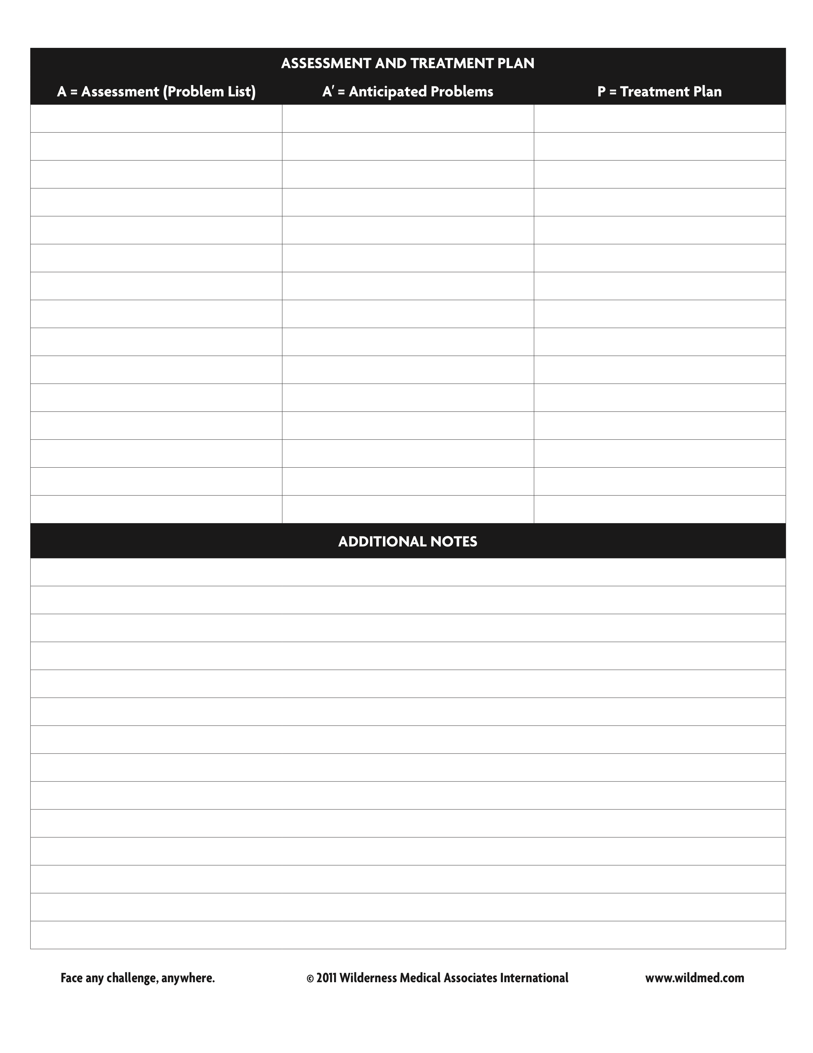

FALL, DESCENDING

An 18 y/o male slipped and fell off a twelve foot (3.6 meter) cliff while descending a peak in the Adirondacks. The fall was observed by the patient’s partner who said he watched his friend fall, land on a patch of dirt, bounce on his side, and then stand up to yell that he was ok. The partner advised the patient to remain still, and the pt. complied. The partner descended and found the patient sitting, breathing rapidly and complaining of pain in his left hip. The patient was alert but extremely anxious. He denied any pain in his neck or back, and he was confident that he never lost consciousness. The pt. stated he had an allergy to codeine, was taking no medication, and stated that he had lunch at 1300. At 1500 hours, the patient was given a complete physical exam, including a spine exam. The patient was non-tender along the spine. His chest and abdomen were non-tender. His pelvis was stable and non-tender with an abrasion noted on the left posterior hip. The CSM in all four extremities was intact. His vitals were as follows: Pulse: 100, Resp: 24, Skin: pale, cool, clammy; mental status: alert and anxious. The rescuer was unable to take a blood pressure.

Put the appropriate information from the above story into the correct spaces provided in the SOAP note.

Develop an Assessment, identify the anticipated problems, and create a treatment plan for this patient, based on what you know at 1500 hours.

By 1545 hours, the pt. had calmed considerably. Another exam was conducted without new findings. His vitals were as follows: Pulse: 80, Resp:16, Skin: pink, warm, dry, mental status: alert, calm, and oriented.

Has your Anticipated Problem list or your Treatment Plan changed at all from 1500 to 1545?
If so, please explain.

QUESTIONS:

- In the above case study, it appears that a spine assessment was completed. Describe in detail the steps of the WMA Spinal Assessment Protocol.

- Please describe what is meant by a “reliable patient.”

- If the patient had complained of tenderness to his sacrum upon exam, but all other physical findings were negative, would you consider this to be a high risk or low risk spine injury? Clearly explain your answer.

WET EXIT, KAYAKING

A staff training group on a remote kayak trip was running a class III section of a river when a kayaker flipped and failed to roll. A 27 y/o male wet exited and was able to self-rescue. He climbed onto a small beach and bellowed in pain. At 0800, the pt. was found sitting up, holding his left arm across his chest, and complaining of pain in his left shoulder. He had a loss of mobility in the shoulder and stated he thought he had dislocated it trying to roll upright. The pt. remembered the event, and denied impact to the shoulder. He also denied any impact to his head, torso, or back. He was alert and oriented. The CSM in three of his extremities was intact. He had good circulation and sensation in the affected shoulder but he had a significantly reduced range of motion. An obvious step off deformity was noted in the left shoulder. The left humerus and clavicle were palpated without obvious instability or deformity. The pt. had sensation in the deltoid muscle of the affected shoulder. The remainder of the physical exam was unremarkable. The pt. stated he was allergic to codeine and took no medications. He added that he had dislocated his shoulder once before about a year previously. His vitals were as follows: Pulse: 88; Resp: 20; Skin: pale, cool; mental status: alert and oriented.

Put the appropriate information from the above story into the correct spaces provided in the SOAP note.

Develop an Assessment, identify the anticipated problems, and create a treatment plan for this patient, based on what you know at 0800 hours.

QUESTIONS:

- Do you believe this patient’s shoulder injury fits the guidelines of the Wilderness Protocol for Dislocation Reduction? Clearly explain your answer.

At 0830, the pt. was made as comfortable as possible and the shoulder dislocation was successfully reduced. Distal CSM was intact pre- and post-reduction. The patient was evacuated (non-urgently) for further evaluation.

- What is your assessment at 0830? That is, how would you describe your patient’s injury or condition post-reduction?

- Do your anticipated problems (A’) change at 0830? Does your Treatment Plan change at all at 0830? Clearly explain your answer.

- If the patient had diminished CSM in this hand even after a successful field reduction of the dislocated shoulder, how would this change your treatment plan or your evacuation plan?

- If the patient had diminished CSM in his hand prior to a reduction, and if the dislocation had been the result of a direct impact, what would your treatment plan be? Clearly explain your answer.

STING, PADDLING

On a whitewater canoeing trip down the Rio Grande River, an18 y/o female stepped from her boat along shore at a popular play spot. Upon exiting, she cried out and flailed her arms and legs as she jumped in the shallow water along the bank. When her fellow paddlers arrived, she stated that she was allergic to bees and she had just been stung, once, on her right shoulder.

At 1300 hours, the pt. complained of intense itchiness on her arms and legs and was extremely embarrassed to be having a reaction in front of others. She said she had a history of allergic reactions to bee stings, and she stated that she had had to use an Epi-pen in the past for severe reactions. She did not have an Epi-pen with her on this occasion. On exam the pt. presented with hives on her chest, back, and face; her eyelids were noticeably swollen. A red swollen welt on her right posterior shoulder could also be seen. Her vitals were as follows: Pulse: 100; Resp: 30 and shallow; Skin: hives on chest, back, face; mental status; awake and anxious.

Put the appropriate information from the above story into the correct spaces provided in the SOAP note.

Develop an Assessment, identify the anticipated problems, and create a treatment plan for this patient, based on what you know at 1300 hours.

Fortunately for this patient, an Epi-pen was available on scene. At 1315, after 0.3 mg of epinephrine and 50 mg of Benadryl was administered, the patient’s condition improved considerably. Her face was less swollen, and though hives were still present, she stated that her skin was less itchy. By 1330, the patient’s hives had decreased. She showed no signs of a rebound or biphasic reaction. Vitals were as follows: Pulse: 84; Resp: 16 and easy; Skin: minor swelling and hives; mental status: alert and oriented.

Modify your SOAP note to reflect the changes in your patient at 1330.

If no medication had been available on scene, how would this change your treatment plan for this patient?

QUESTIONS:

- According the WMA’s guidelines, which signs and symptoms indicate that a patient who is experiencing an allergic reaction has progressed from a mild allergic reaction to anaphylaxis ?

- Describe the specific treatment steps (medications and dosages) in the WMA Anaphylaxis Protocol.

- If this patient was in a remote environment, and evacuation was difficult and/or impractical, what additional medication, including dosage, could be given (if available)?

BEAR ATTACK, HIKING

At 1500, on a beautiful autumn day, a solo hiker decided to take a short hike. Not far from the trailhead he surprised a brown bear and ended up being mauled. Three other hikers who were in the area discovered the pt. soon after the attack. The three sent one of their group members to get help while the other two stayed behind to help take care of the pt.

A rescue group arrived at 1700 hours. Upon questioning, the patient stated that the bear bit him several times on the arms. The bear then bit him on the foot and pulled off his boot. The patient had tried to walk out barefoot, but he was unable to walk without his boot. The pt. complained of pain in both arms and his right foot. He stated he had no allergies, took no regular medications, and he had no idea when his last tetanus shot was. He had been drinking water and snacking all day. He remembered the attack in vivid detail. Upon exam, it was noted that the pt. had four puncture/crush wounds of approximately one inch (2.5cm) in depth to each forearm. The wounds had resulted in some moderate blood loss but none of the wounds was actively bleeding at the time of the exam. A three inch (7.5cm), fairly shallow laceration was noted on the bottom of the patient’s right foot. The pt. had blood on his face and neck, but the blood appeared to have come from his arms as no additional wounds were noted. His vitals were as follows: Pulse: 86; Resp: 20; Skin: pink, warm, and dry; mental status: alert and oriented, but anxious. The rescuers were unable to take the patient’s blood pressure.

Put the appropriate information from the above story into the correct spaces provided in the SOAP note.

Develop an Assessment, identify the anticipated problems, and create a treatment plan for this patient, based on what you know at 1700 hours.

At 1730 hours, the patient’s vitals were take again and were as follows: Pulse: 78; Resp: 14; Skin: pink, warm, ad dry; mental status: alert and oriented, but anxious that the bear would return. At 1730, the patient began complaining of being cold and started to shiver.

Modify your SOAP note to reflect any changes noted at 1730.

This incident occurred roughly one hour (by foot) from a trailhead; the trailhead was a 1.5 hour drive to the nearest clinic. If the patient is able to walk, an assisted walk out (to the trailhead) would take around three hours. If the patient is unable to walk, a litter carry-out would take about three hours (to the trailhead). An ATV is available nearby, but it would take around three hours to get the ATV to the patient. There are no major weather concerns other than cooling temps.

Given this new information, please describe your evacuation plan.

QUESTIONS:

- Describe the steps of the WMA Wound Cleaning Protocol.

- How urgently does this patient need to be evacuated to definitive care?

- What signs/symptoms or conditions would increase the urgency of this evacuation?

FALL, SKIING

A group of young males, inspired by sunny weather, skied out of bounds, into a area that had a reputation for steep-chute skiing. The conditions at the time were treacherous; the chutes were sheathed in ice from days of a recent melt/freeze cycle. Two of the skiers chose one of the steepest and tightest of the chutes as their descent route. Both lost control almost immediately after skiing onto the slope. Witnesses stated that the two picked up speed, lost their equipment, and started bouncing off trees before disappearing into the bottom of the chute. The uninjured skiers reported the accident to nearby ski patrollers. Although the responders responded as soon as possible, 45 minutes passed (from time of incident) before rescuers reached the patients. The first patrollers arrived at 1000 hours to find one young male at the base of a tree; the second skier was found at the bottom of the chute.

On exam, patient #1 was unresponsive and pulseless. After checking his carotid pulse for a full minute, the patient was determined to be in cardiac arrest.

On exam patient #2 was found with gurgling respirations. He was pain responsive. Significant trauma was noted on his head with deformity and swelling around the face and the posterior skull. Patient #2 had a significant amount of blood in his airway. The airway was immediately cleared and PPV was initiated. The patient presented with severe respiratory distress. There was crepitus noted in his L anterior and lateral chest wall. Breath sounds were absent on the L side. His anterior abdomen was distended and tender. No gross deformities were noted in the extremities, but the patient moaned loudly when his lower extremities were stabilized or moved. The CSM in all four extremities appeared to be intact.

Patient #2’s vitals were as follows: pulse: 140 and weak; Resp: 40 and extremely labored: B/P: 180 /p; Skin: pale, cool, moist; mental status: P on AVPU. The patient’s temperature was not taken.

Put the appropriate information from the above story into the correct spaces provided in a SOAP note for each of the above patients.

Develop an Assessment, identify the anticipated problems, and create a treatment plan for patient #2, based on what you know at 1000 hours.

Once the patient reached the base of the mountain, a helicopter was available. The evacuation time from the scene (after patient packaging) was roughly 20 minutes to the base area. It was an additional 30 minutes by air to the Trauma Center.

QUESTIONS:

- Do you believe it is appropriate for the rescuers in this case study to start CPR on PATIENT #1? Describe why or why not.

- Based on the WMA CPR Protocol, why might you stop performing CPR on a patient in the backcountry?

- If this accident occurred in a remote location and you had to spend the night out, what specific steps could you take regarding patient care, patient warmth, etc., to give patient #2 the best chance of survival?

